Lab10 Post Lab
Team Number: 48
Team Members: Shihong Yuan(syuan19),Liangbing Zhao (lz36), Daniel Koltchev (dvk2),Sebastian Misong (missong2)
Section1

Q1. Plot
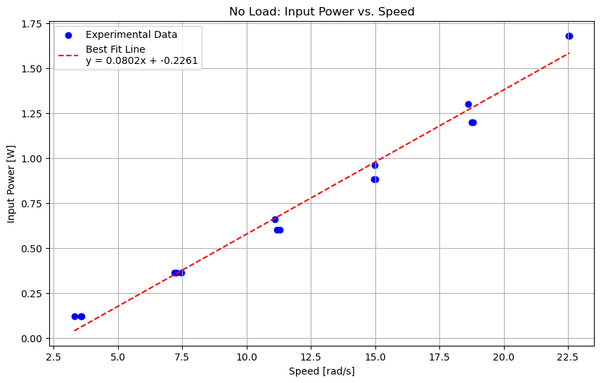

Table 1- Station A-no load testing
Test # | Voltage (V) | Current (A) | Speed (rpm) | Speed (rad/s) | Input Power (W)
1 | 2 | 0.06 | 31.5 | 3.29867229 | 0.12
2 | 2 | 0.06 | 33.9 | 3.5499997 | 0.12
3 | 2 | 0.06 | 34.3 | 3.5918876 | 0.12
4 | 4 | 0.09 | 68.7 | 7.19424718 | 0.36
5 | 4 | 0.09 | 69.5 | 7.27802298 | 0.36
6 | 4 | 0.09 | 71.3 | 7.46651854 | 0.36
7 | 6 | 0.11 | 105.9 | 11.08982207 | 0.66
8 | 6 | 0.10 | 106.9 | 11.19454182 | 0.6
9 | 6 | 0.10 | 107.8 | 11.2887896 | 0.6
10 | 8 | 0.12 | 143.0 | 14.97492498 | 0.96
11 | 8 | 0.11 | 143.4 | 15.01681288 | 0.88
12 | 8 | 0.11 | 142.8 | 14.95398103 | 0.88
13 | 10 | 0.13 | 177.8 | 18.61917246 | 1.3
14 | 10 | 0.12 | 179.1 | 18.7553081 | 1.2
15 | 10 | 0.12 | 179.5 | 18.7971960 | 1.2
16 | 12 | 0.14 | 215.2 | 22.5356913 | 1.68
17 | 12 | 0.14 | 215.4 | 22.5566352 | 1.68
18 | 12 | 0.14 | 215.2 | 22.5356913 | 1.68

Q2. Relationship Explanation
Based on the "No Load: Input Power vs. Speed" plot you provided, the relationship between input power and speed is approximately linear.
As the motor's speed (rad/s) increases, the input power (W) it consumes also increases. This positive correlation is clearly shown by the upward trend of the experimental data points and the positive slope (0.0802) of the red best-fit line.

Section2
Q1
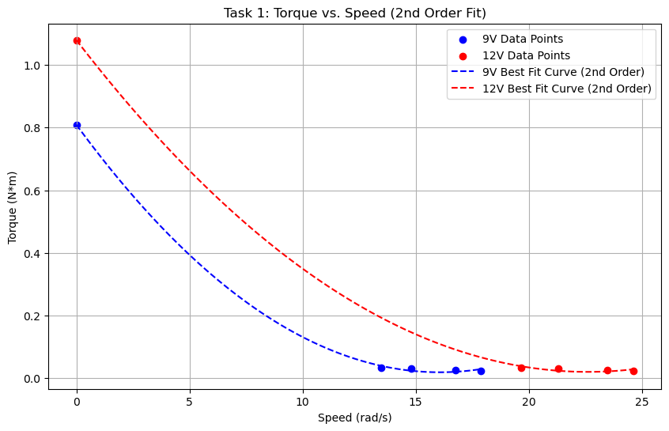
9V : Torque = 0.00306 * Speed^2 + (-0.09834) * Speed + (0.80882)
12V : Torque = 0.00207 * Speed^2 + (-0.09362) * Speed + (1.07889)

Q2
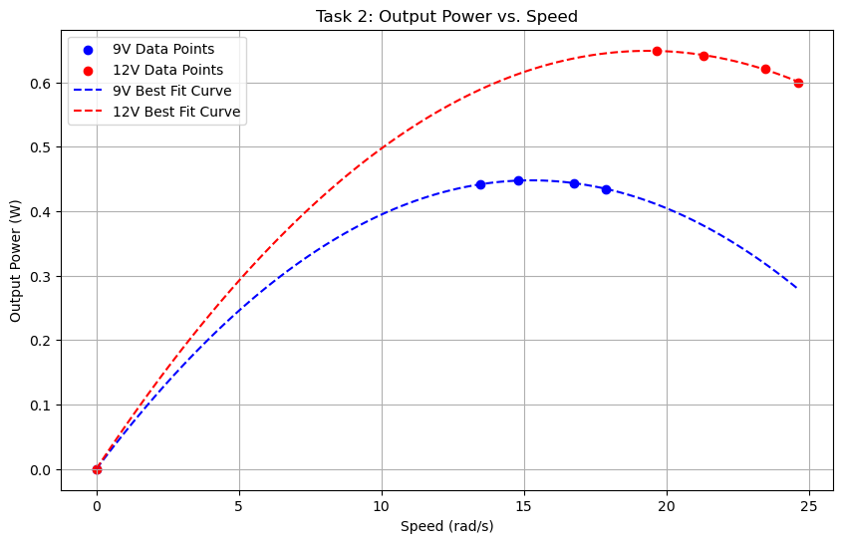
9V : Power = -0.0019 * Speed^2 + 0.0587 * Speed + -0.0000
12V : Power = -0.0017 * Speed^2 + 0.0670 * Speed + 0.0000

Q3
At low speeds (as speed $ω$ approaches 0), the torque is at its maximum. This is the "stall torque," representing the maximum rotational force the motor can provide. However, because output power is calculated as $P=T⋅ω$ (Torque x Speed), and the speed ($ω$) is zero, the output power is also zero.
At Intermediate Speeds (Working Range): As the motor speeds up from zero, the torque begins to decrease, but the speed ($ω$) is increasing. In the equation $P=T⋅ω$. The increase in speed initially has a greater effect than the decrease in torque. This causes the output power ($P$) to rise rapidly, as shown by the upward slope of the parabolic curve. The motor reaches its maximum output power at the peak of this curve, which theoretically occurs at half the no-load speed and half the stall torque.
At high speeds (as the motor approaches its maximum "no-load" speed), the motor spins freely, and the output torque drops to near-zero. At this point, the motor is only producing enough torque to overcome its own internal friction and air resistance, leaving no useful torque for an external load. Consequently, because the torque ($T$) is near-zero, the output power ($P=T⋅ω$) is also zero

Tables 2 and 3- Station B: Load Testing
Table 2. Load Testing, Voltage = 9V
Torque(N*m) | Speed (rpm) | Speed (rad/s) | Output Power (W)
T1=0.024 | 170.774 | 17.883 | 0.4344
T2=0.026 | 159.902 | 16.745 | 0.4439
T3=0.030 | 141.258 | 14.793 | 0.4473
T4=0.033 | 128.804 | 13.488 | 0.4418
Tstall = 0.809 | 0 | 0 | 0

Table3.Load Testing, Voltage = 12V

Torque(N*m) | Speed (rpm) | Speed (rad/s) | Output Power (W)
T1=0.024 | 235.180 | 24.628 | 0.5999
T2=0.026 | 224.238 | 23.482 | 0.6209
T3=0.030 | 203.269 | 21.286 | 0.6409
T4=0.033 | 187.634 | 19.6490 | 0.6492
Tstall=1.079 | 0 | 0 | 0

Section3

Q1
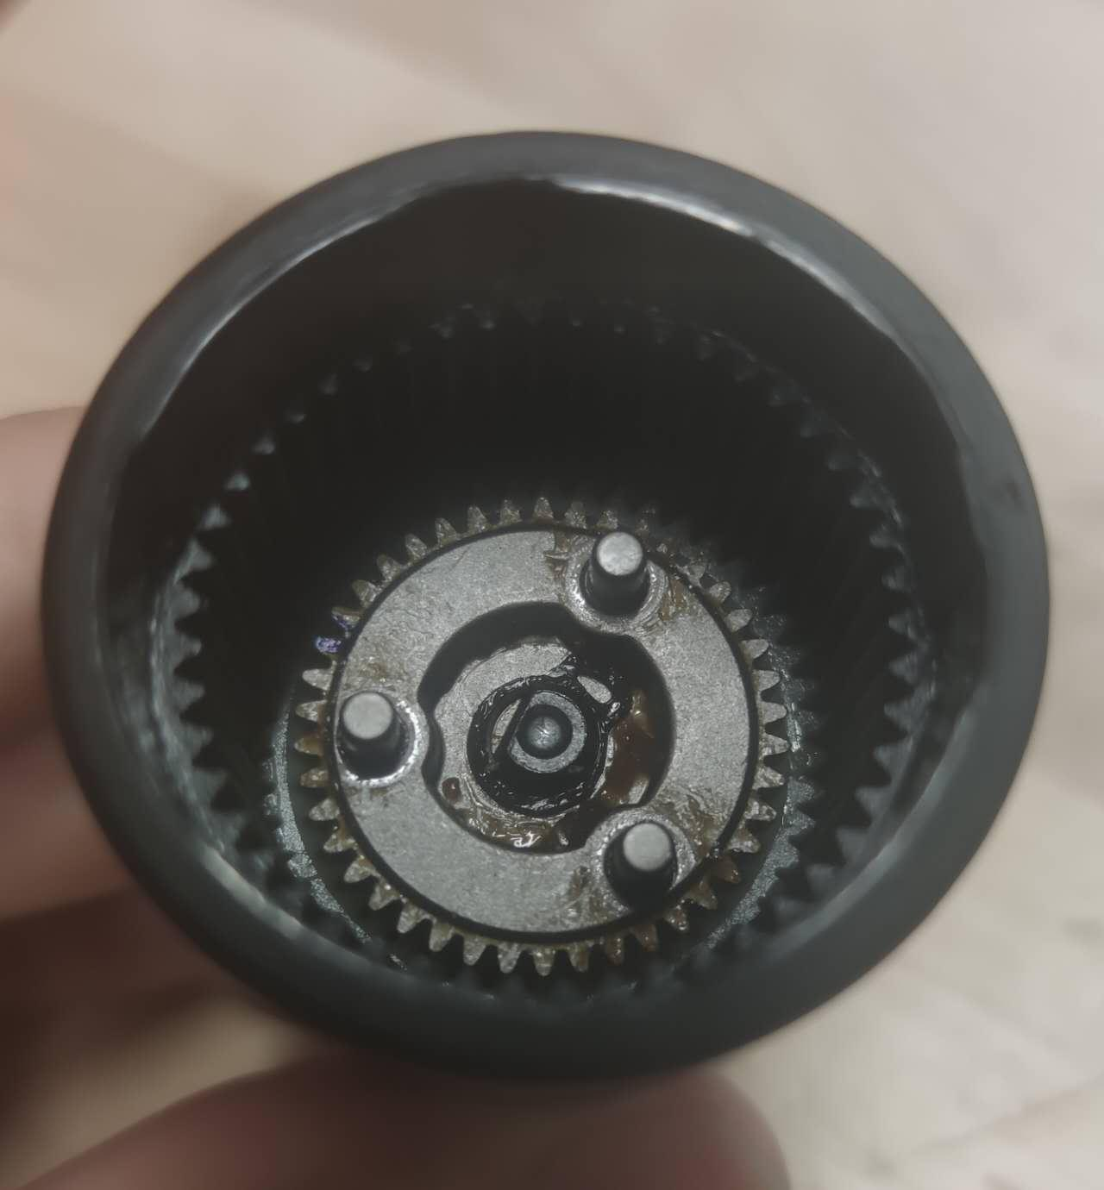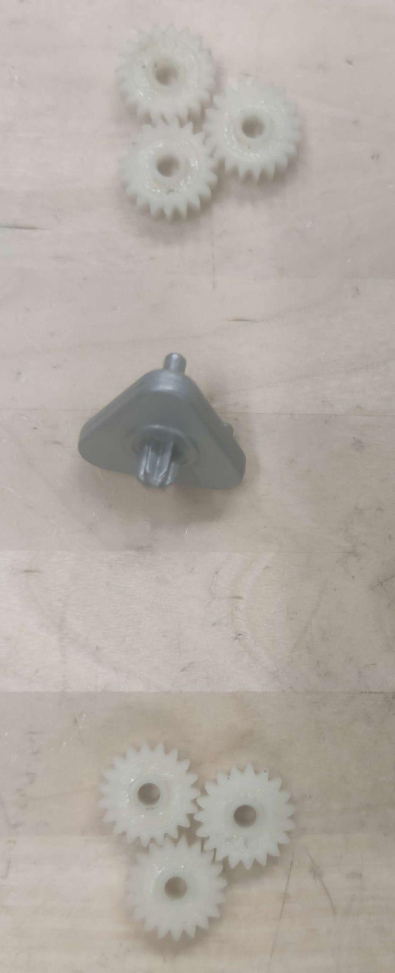

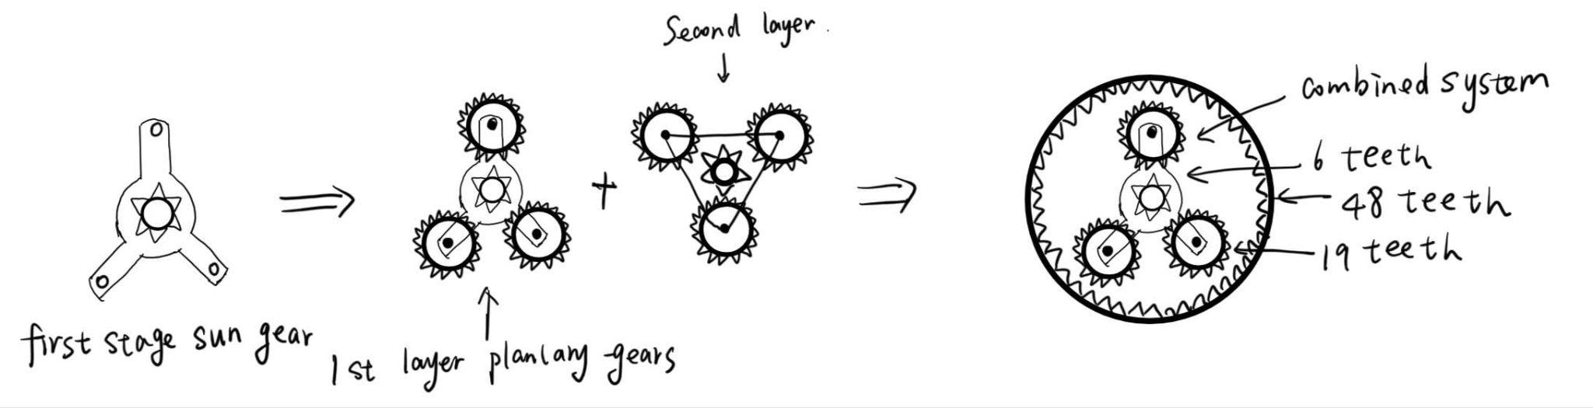

Q2

Stage1:
Sun gear:6
Planet gear:19
Ring gear:48

Stage2:
Sun gear:6
Planet gear:19
Ring gear:48

Q3
Input: Sun Gear
Fixed: Ring Gear
Output: Planet Carrier
$i_{stage}=\frac{w_{sun}}{w_{carrier}}=1+\frac{N_{r}}{N_{s}}$
$i_{total}=i_{1}⋅i_{2}=(1+\frac{N_{r}}{N_{s}})^{2}$

Q4
Gear ratio: I = (1+48/6)*(1+48/6) = 81

Q5
Planetary gear systems are ideal for drill transmission because:
- They provide a high reduction ratio in a compact and coaxial design, allowing large torque output while keeping the drill small and lightweight.
- The load is shared among multiple planet gears, which increases strength, durability, and efficiency.
- They offer smooth, balanced rotation with minimal vibration and noise, improving tool stability and user comfort

